Yellen Says Restraining the Fed’s Oversight Would Be a ‘Grave Mistake’
By BINYAMIN APPELBAUMJULY 16, 2014
Inside
Photo
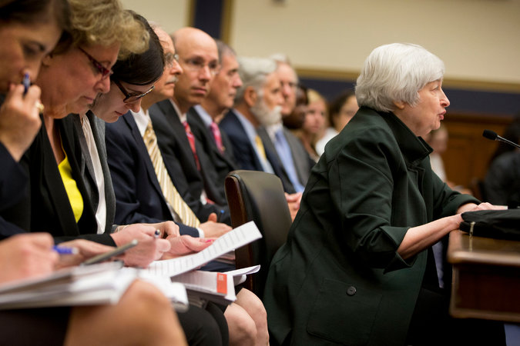
Janet L. Yellen of the Fed said a proposed bill would impair its ability to manage the economy. Credit Pablo Martinez Monsivais/Associated Press
Continue reading the main story
WASHINGTON — The Federal Reserve’s chairwoman, Janet L. Yellen, said on Wednesday that it would be a “grave mistake” for Congress to adopt legislation proposed by House Republicans constraining the Fed’s management of monetary policy.
Ms. Yellen and Republican lawmakers traded strong words during a testy hearing before the House Financial Services Committee that focused on a bill that would require the Fed to publish a set of rules for raising and lowering interest rates.
Ms. Yellen said such a rule would impair the Fed’s ability to manage the economy, even inhibiting its ability to respond to financial crises. It “would essentially undermine central bank independence,” she said.
Republicans criticized what they described as an alarmist response by Ms. Yellen and Democrats to a proposal that they said would do nothing more than modestly increase the Fed’s accountability by requiring greater transparency.
They emphasized that the legislation did not specify a particular rule — it simply told the Fed to pick one. The committee’s chairman, Jeb Hensarling, a Texas Republican, sharply criticized what he described as “howling protests and apocalyptic visions from my Democratic colleagues,” calling them “apologists for the status quo.”
“The Fed can set any rule it wishes,” Mr. Hensarling added. “It can change the rule any time it wishes. It can deviate from the rule any time it wishes.” Under the proposed bill, he added, “it simply has to report and explain this to the rest of us. That’s what transparency and accountability are all about.”
The sparring largely overshadowed questions about the current course of Fed policy, in the face of mounting evidence that the economy has recovered from a rocky winter.
The Fed’s Beige Book, an anthology of economic impressions gathered by the Fed regional banks and released two weeks before meetings of the Federal Open Market Committee, reported that growth continued at a “modest to moderate pace” throughout the country.
The report was consistent with recent data showing stronger job growth and improvements in manufacturing activity. On Wednesday, the Fed reported that manufacturing output increased 0.1 percent in June, a modest increase that capped a strong quarter during which factory production advanced at an annual rate of 6.7 percent.
Another report, from the Labor Department, found producer prices rebounding 0.4 percent last month after a decline of 0.2 percent in May, also showing signs of a healthier manufacturing sector. The government will publish an initial estimate of second-quarter economic activity at the end of July.
The evidence of faster growth has revived concerns that the Fed will need to move more quickly. The central bank plans to end the expansion of its bond holdings in October. Ms. Yellen did not give a direct answer on Wednesday to questions about how soon the Fed would begin to raise its key short-term gauge from its current rate near zero, but she did note that most economists expected the Fed to act in the third quarter of 2015.

Some Fed officials and economists say that is not soon enough. Richard W. Fisher, president of the Federal Reserve Bank of Dallas, said on Wednesday that the Fed should start raising rates early next year.
“We are at risk of doing what the Fed has too often done: overstaying our welcome by staying too loose too long,” he said. “I believe the time to dilute the punch is close upon us.”
James Bullard, the president of the Federal Reserve Bank of St. Louis, also has warned in recent weeks that he now expects inflation will rise above the Fed’s target next year.
Ms. Yellen has largely played down such concerns, describing inflation as muted and unlikely to rebound strongly. She remained primarily concerned about reducing unemployment and expediting the incomplete recovery.
Citing “substantial headwinds” impeding growth, she said, “Until they are completely gone, it calls for an accommodative monetary policy.”
Her testimony to Congress, however, included an acknowledgment that the Fed would act sooner if the recovery, particularly in the labor market, continued to outstrip expectations.
The hearing on Wednesday had this debate about current policy as its subtext.
The Republican-sponsored bill introduced last week would require the Fed to adopt something like the Taylor Rule, a formula written by the Stanford economist John Taylor that specifies interest rates based on inflation and the gap between actual and potential economic output. The Fed could change the rule, but it would be required to explain deviations.
Mr. Taylor said last week that his rule would now require the Fed to set short-term interest rates at around 1.25 percent.
Ms. Yellen, in making the case that the Fed needs flexibility, is also arguing that it needs to maintain lower rates to reduce unemployment further.
Representative Bill Huizenga, a Michigan Republican who was a co-author of the bill, asked Ms. Yellen whether she had read the legislation, waited for a response, and then said he would refresh her memory. He said the point of the bill was to establish accountability. “We cannot have an entity within the federal government just operating on a whim,” he said.
Ms. Yellen responded that the Fed was “the most transparent central bank to my knowledge in the world.”
Democrats rallied to Ms. Yellen’s defense, contending that Congress already had sufficient oversight of monetary policy. Maxine Waters of California, the committee’s ranking Democrat, called it a “recipe for disaster.”
Democrats also urged Ms. Yellen to persist in holding down interest rates.
“The economy is worse than your statement indicates,” Representative Brad Sherman, a California Democrat, told Ms. Yellen.
“There isn’t a person in this room who has waxed eloquently about how everything’s going spectacularly in their district,” he said. “And many, many members have told me and spoken about how, in a very large percentage of this country, we’re still in recession.”
A version of this article appears in print on July 17, 2014, on page B3 of the New York edition with the headline: Yellen Says Restraining the Fed’s Oversight Would Be a ‘Grave Mistake’. Order Reprints|Today's Paper|Subscribe

